Weather Widget - Solution Design

Table of Contents

Overview 2

What's inside? 2

Laying out design decisions and assumptions 3

Accessibility 4

To do / Roadmap 5

# Overview

This weather application provides current and 24 hour 7-day weather forecast for any city in the world built with using React. Weather forecast data is powered by OpenWeatherMap and city search data is powered by Algolia Places.

# What's inside?

A quick look at the top-level files and directories in this weather-react project.

├── public

├──favicon.ico

├──index.html  
├── src

├──__tests__  
 ├── api

├──placeSuggestions

├──type

├──weather

├── assets

├── components

├── Header

├── Footer

├── Search

├── Forecast

├── Weather

├── WeatherIcon

├── ui

├── hooks  
 ├── pages  
 ├── store  
 ├── utils  
├── App.js  
├── index.js  
├── setupTests  
├── theme

* **api**: This directory contain all of the code related to the back-end of the application dealing with third party APIs
* **public**: This directory contain favicon and index.html file
* **assets**: This contains al lassets like images, icons used
* **src**: This directory contain all of the code related to what you see on the front-end of the application. src is a convention for “source code”.

# Laying out design decisions and assumptions

Landing page – This is the first page you see when you access the web app. It contains a search bar to search for location specific weather.   
If you need to

This is an autocomplete container with suggestions which maps the location using Algolia places API.

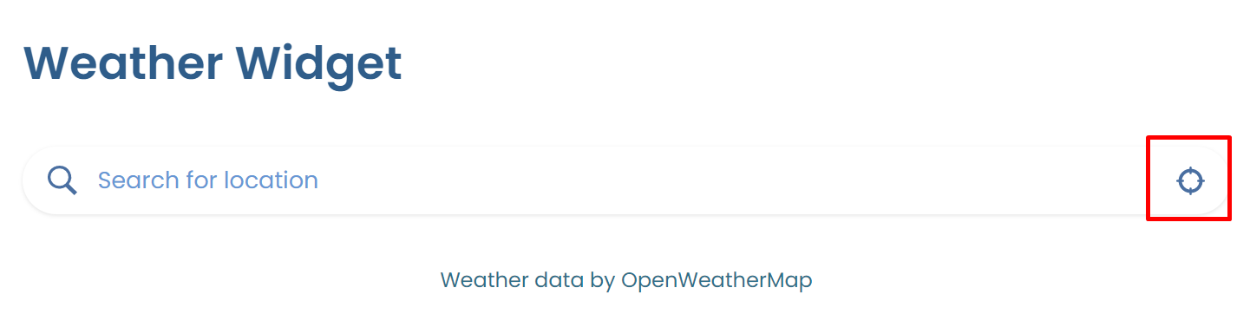

* Weather card – This layout is divided into a main <WeatherContainer> which consists of a <CurrentWeatherContainer>. This contains the <CurrentWeather> on the left showing the current city name, weather icon, temperature & description.

On the right hand side you have the <CurrentWeatherInfo> which consists of the row of infos including icons for humidity, wind and pressure.

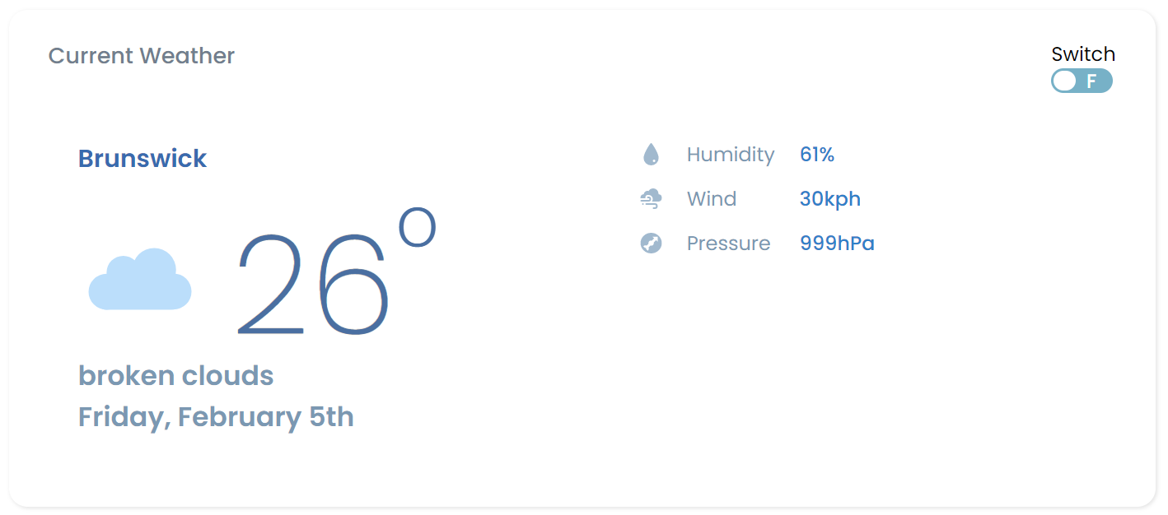

* Toggle slider – This component is part of the ui which can toggle the temperature to ‘Imperial’ or ‘Metric’ triggering an action from the redux store to do conversions
* Forecast Card – This layout is divided into column format where the weeks forecast is mapped into <ForecastItem> component

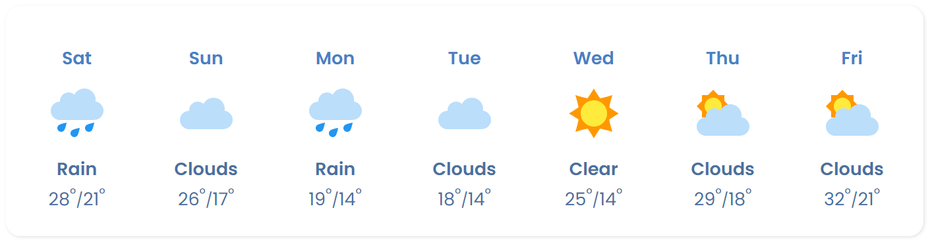

# Accessibility

Aria-labels have been used within this application to provide recognizable label-text for objects on the screen as per WAI-ARIA docs (<https://www.w3.org/TR/wai-aria/#usage>)

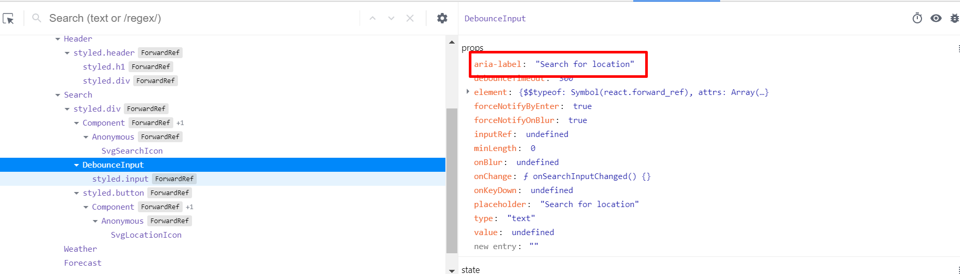

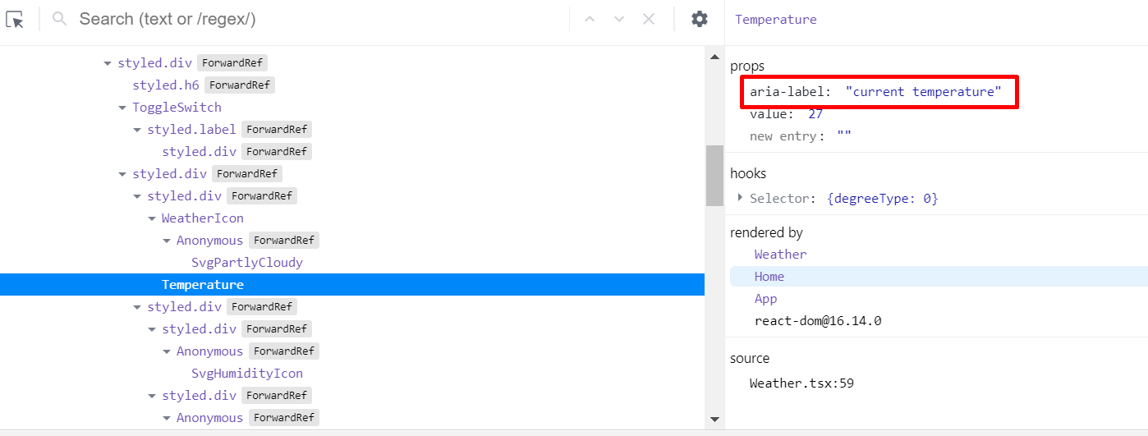

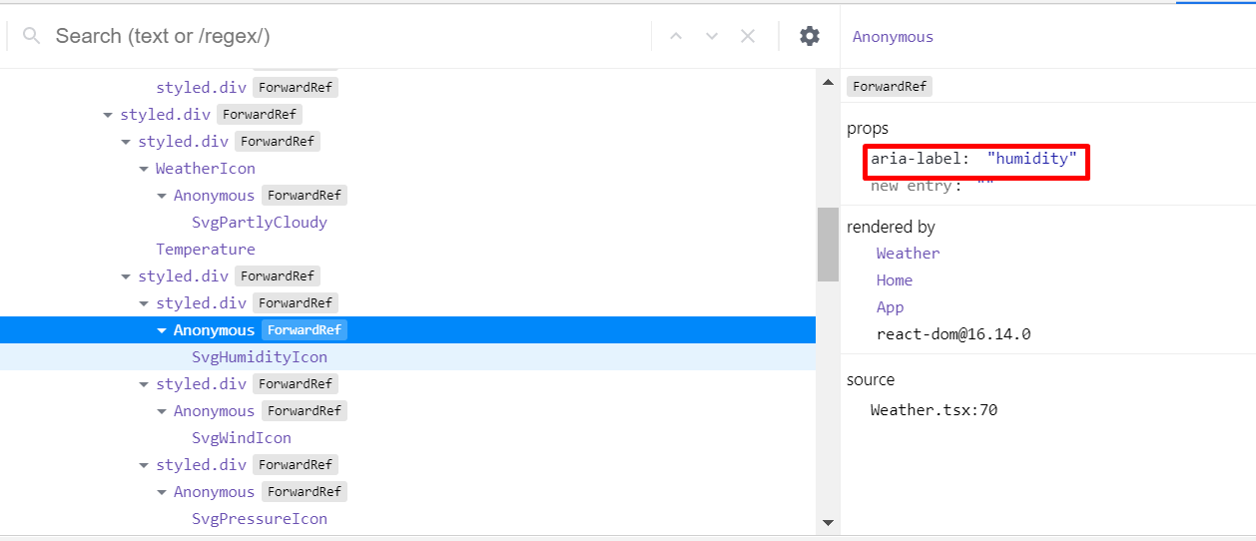

# To do / Roadmap

* Build a proxy server using for handling API requests
* Unit testing is limited at the moment. Need to add more relevant test scenarios for TDD
* Few data elements are not currently available on OWM API (like precipitation & pollen count). Need to check if these are accessible at any other endpoints
* Create some mock data to test APIs
* Add documentation for components using **Storybook**